WILLIE’S STORY

Wilhelmina Catharina Katarski (nee Groenewoud)

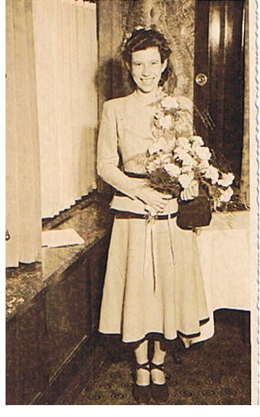
Wilhelmina on her Wedding Date 28 April 1949

On August 1939 my sister and myself went to Holland for me to study Domestic Science and my sister for Secretary for External Affairs. In May 1940 we got a phone call from my parents that we had to come back home (Bandung on Java) because it looked like war. My sister and I left Holland on the 10th May 1940, the last boat with over 300 people on board. If you couldn’t pay for the trip you were not allowed on board. We were still in Holland when the Germans came in, but left just in time. Our trip to Java was on the “Johan the Wit” and it took 2 months. We had to go around the Cape because of all the mines. We were not allowed to go to bed and had a life vest to wear for just about the whole trip. All the windows were covered and the ship proceeded in black out conditions at night.

After our arrival in Bandung (Java W) I went to Surabaya (E. Java) to take up my studies and my sister hers. But in the beginning of 1940, the war broke out and in 1942 the Japanese invaded and I had to stop my study again. In 1942 the Japanese put us in camps - the first one for about one year with 5 couples in one house. We each had one bed-sitting room. After that we were transported to Ambarawa Camp 6. That lasted for approx. 2 years. You can read the book “50 Years of Silence” by Jan Ruff-O’Herne. (a brief summary of Jan Ruff O’Hearne’s story is that several thousand women and children were housed in an old barracks which had been designed for a couple of hundred soldiers. It was infested with lice, bugs, cockroaches and rats. There was little water with poor sanitation. They were subjected to roll calls (Tenko) and had to bow deeply from the waist to the Japs. The women had to work hard and be obedient. Many were punished and some even killed. Babies died because mothers’ milk dried up. Food was short and the children learned to scavenge in the Japanese rubbish bins. The Japs took their valuables (jewellery and money). Death was always around them. The Japanese took a number of the younger girls and forced them to work in a brothel, providing services for their troops. ) We were in the same camp (part 2 in the above book). We were not raped, because we arrived 1 day after the girls were taken away to the brothels. Every day we would say “tomorrow, tomorrow”, but it took a long time before tomorrow came.

We were staying in barracks and every night before we went to sleep we talked about nice things. Often we were waiting late at night for something to eat and they would call out “nothing left”. If we got an egg we saved it that long until it was no good anymore. My sister was working in the kitchen and could sometimes bring some rice for my mother. My youngest sister had bad berri-berri. I could hardly eat the stuff and lost a lot of weight. One thing was a blessing, none of the women had a period all those years.

At about the end of 1944 we were transported to another camp, Camp 8 also in Ambarawa. The camp was a big Catholic school and we had to sleep on the floor. We used the few clothes we had as a pillow. I was so thin I could hardly walk anymore. In August 1945 the Japanese had left, but didn’t tell us. That same day Indonesian people climbed over the fence. We had to gather on a sort of a playground. Then they started to shoot at us and throw hand grenades. 15 women died. My mother and us 3 sisters came out alright. We still had to stay in the camp until the army freed us. After that we still went to another camp for about a fortnight. Then we had a chance to go to Bangkok for 6 months. We couldn’t go back to Bandung, where my father was waiting. My brother was picked up on the street without saying goodbye. He was in a boys camp. My father was in a different camp again. After approx. 6 months in Bangkok we went to Holland, where my father and brother were waiting. We stayed with my aunty and uncle for a few months until we were on our own again. And after that we lived happily ever after.

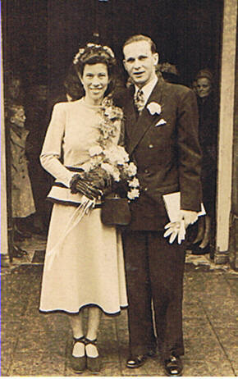
Mr & Mrs Oleg Kataraski
Wedding Day 28 April 1949

Willie Katarski September 2006

