THE LOST YEARS
1940-1945

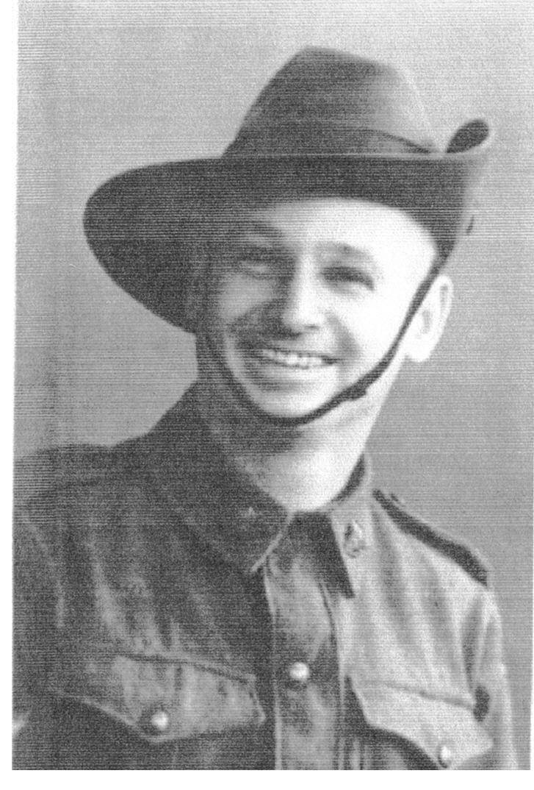

Francis John Giles was born in Broken Hill, New South Wales on 10 February 1902.
He served in the Australian Imperial Expeditionary Force for a period of 189 days until his discharge on 8 May 1921.

He later enlisted in the Australian Imperial Force (AIF) on 10 December 1940. He was posted to the 2/5 Field Hygiene Section and sailed for Singapore on 27 January 1941. Whilst in Singapore he was promoted to Sergeant and subsequently appointed a Staff Sergeant.

Following the capitulation of Singapore on 15 February 1942 he became a Prisoner of War. He was moved as part of “A” Force to Burma in May 1942 and toiled there until the line was completed late 1943.

John wrote an account of his experiences under the nom de plume “F.Mauri”. The account is very revealing of conditions and incidents prevailing in his area.

The account has been kindly provided to me by his son John Giles of Baulkham Hills Sydney, New South Wales.

Lt Col Peter Winstanley OAM RFD (JP) email pgwinstanley@cambraivillage.com.au

